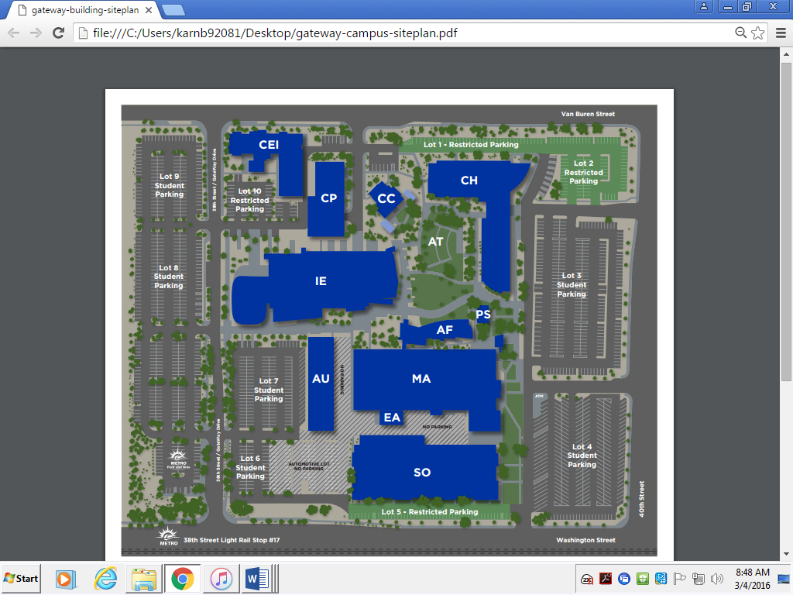

**GateWay Community College 108 N. 40th St.**

The Copper Room is located in the IE building (indicated here with a yellow star). It is most convenient to park on the West side of campus (indicated here with red stars). If you are entering campus from Van Buren, you will go south on 38th Street/Gateway Dr. If you are entering campus from Washington, you will go North on 38th St./ Gateway Dr. The door on the west side of the building will be open (indicated with a gold arrow).